**Day 8 (07 June 2025)**

**112552596 - vsisukhw - Sukhwinder Singh**

**Task25 and 32 please remember, they are 2**

**Task 021**

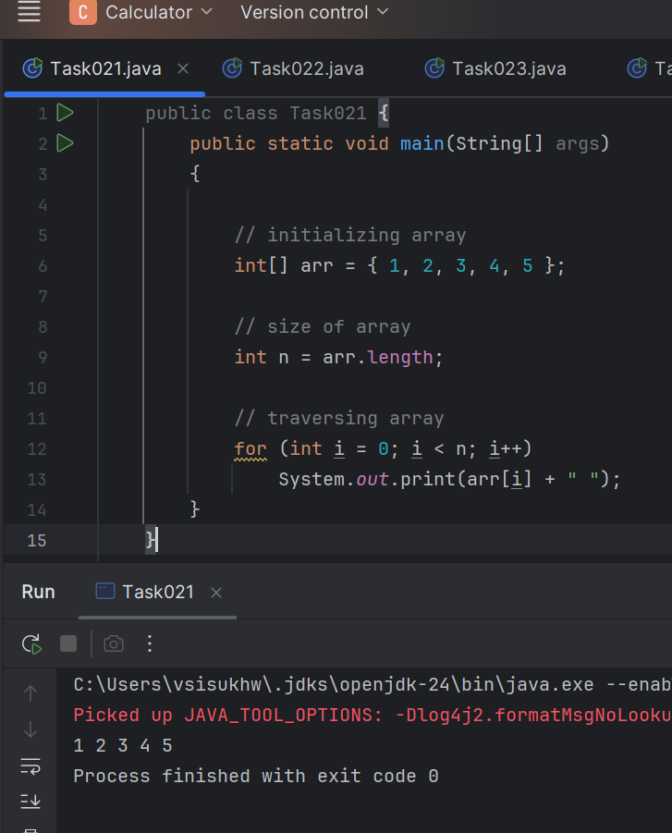

**Task 022**

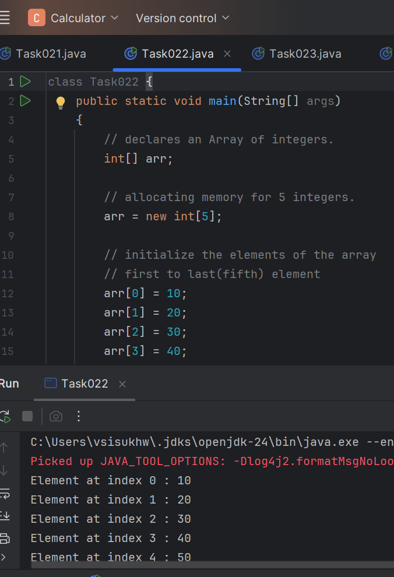

**Task 023**

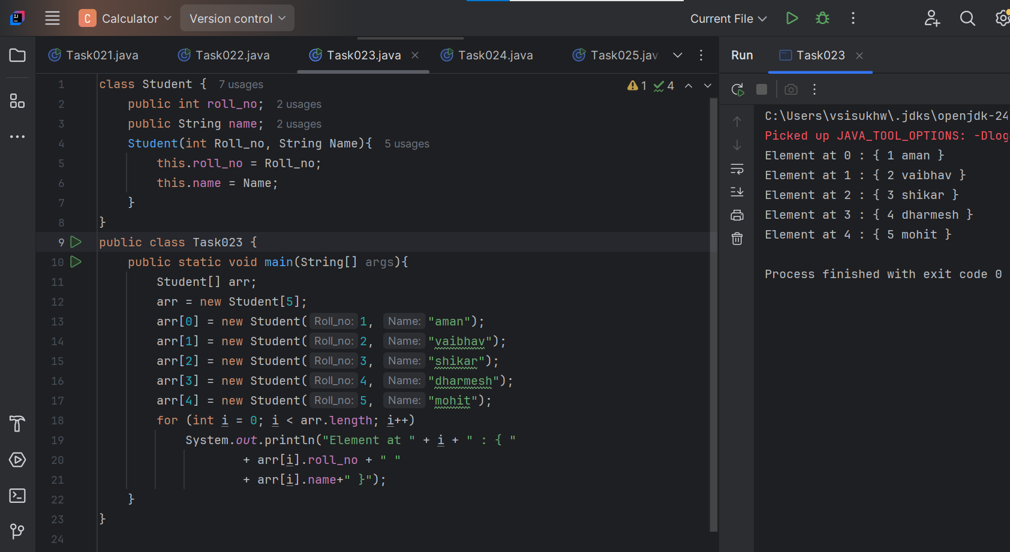

**Task 024**

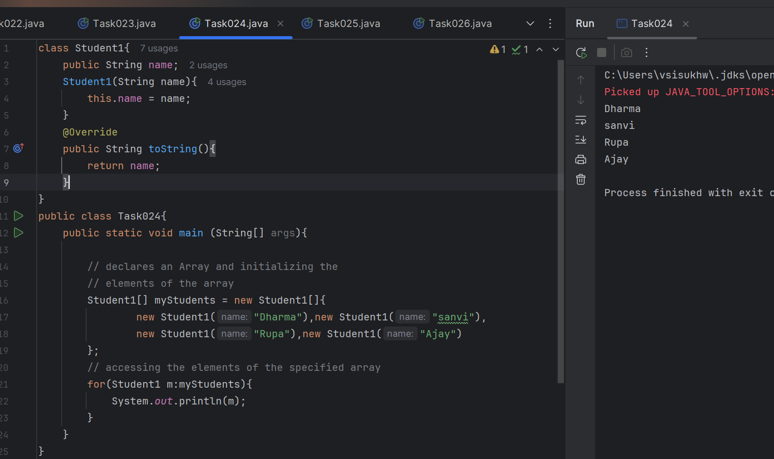

**Task 025**

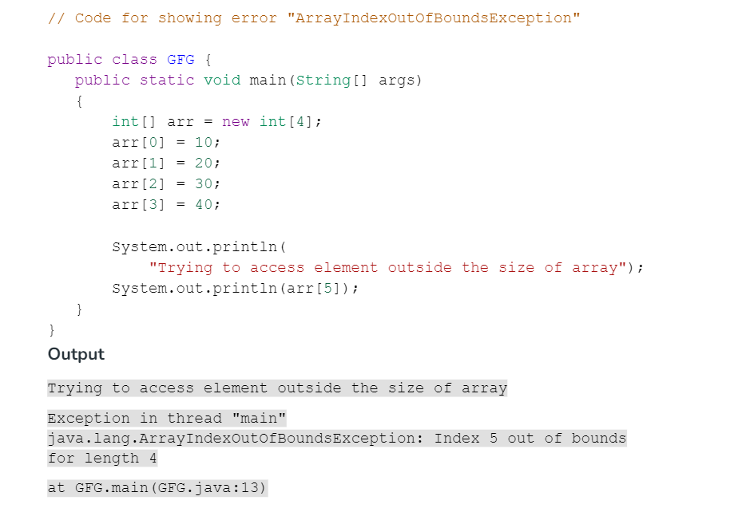

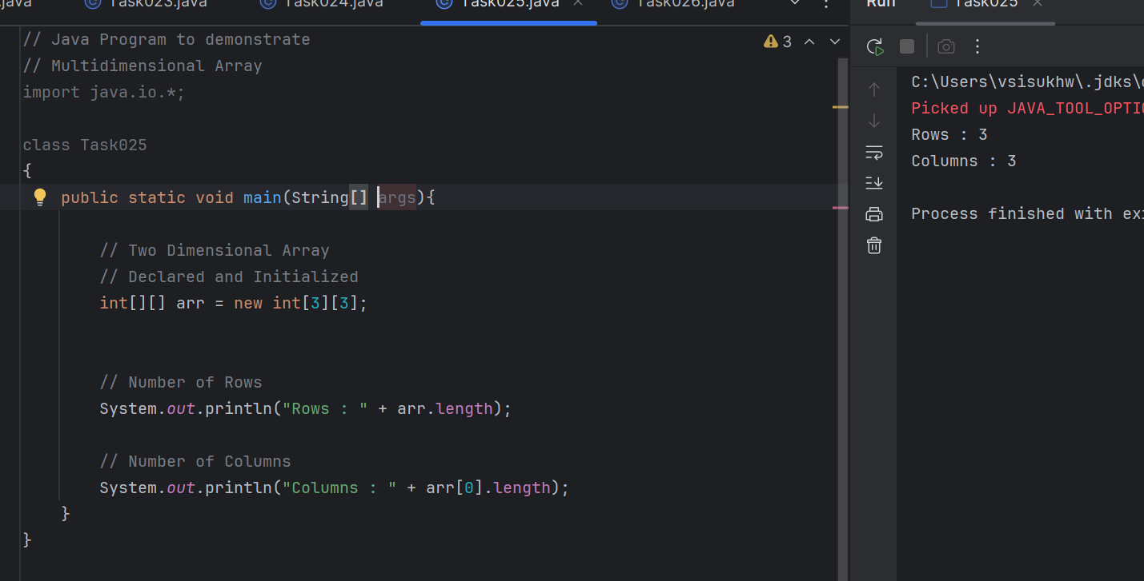

**Task 026**

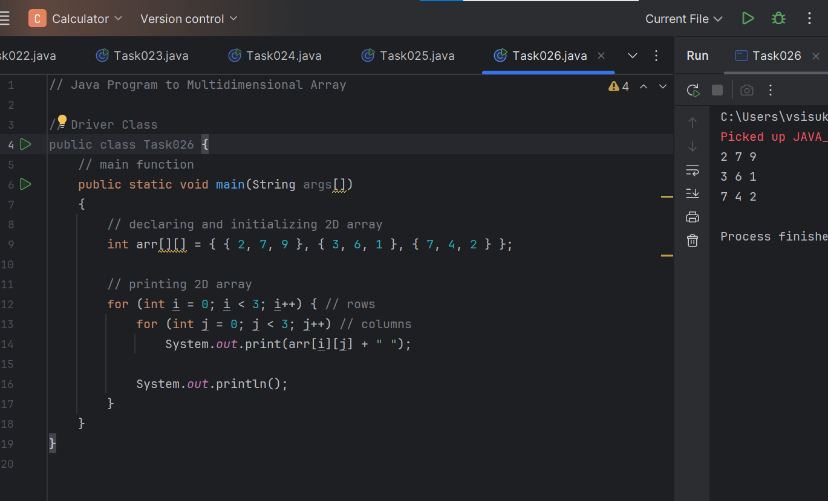

**Task 027**

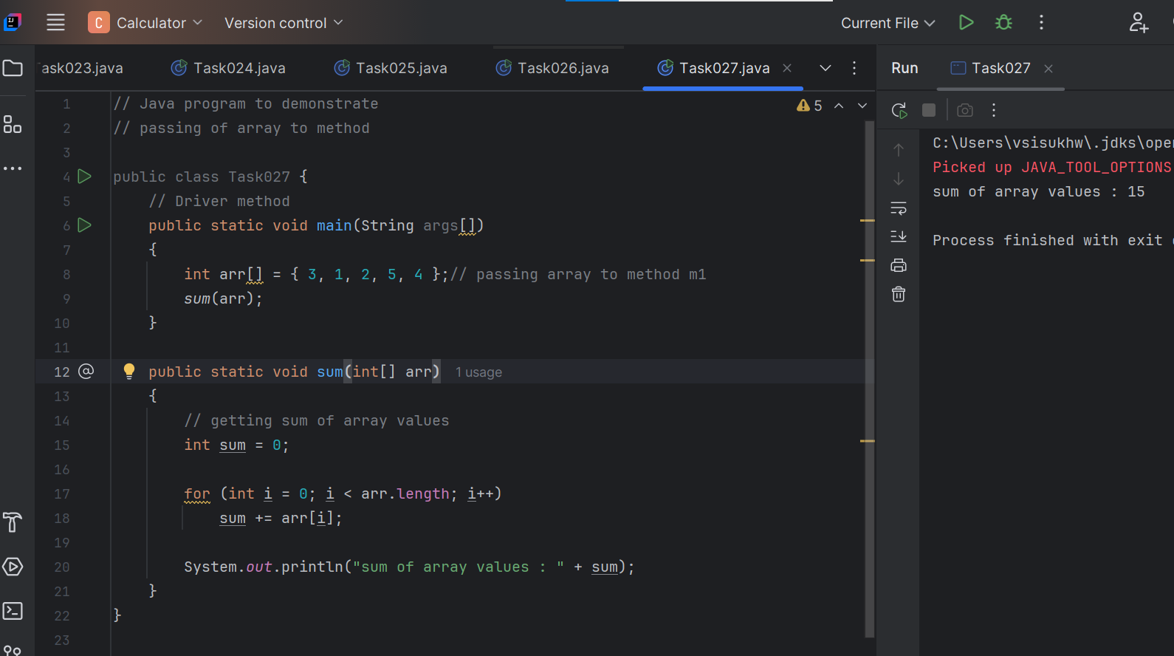

**Task 028**

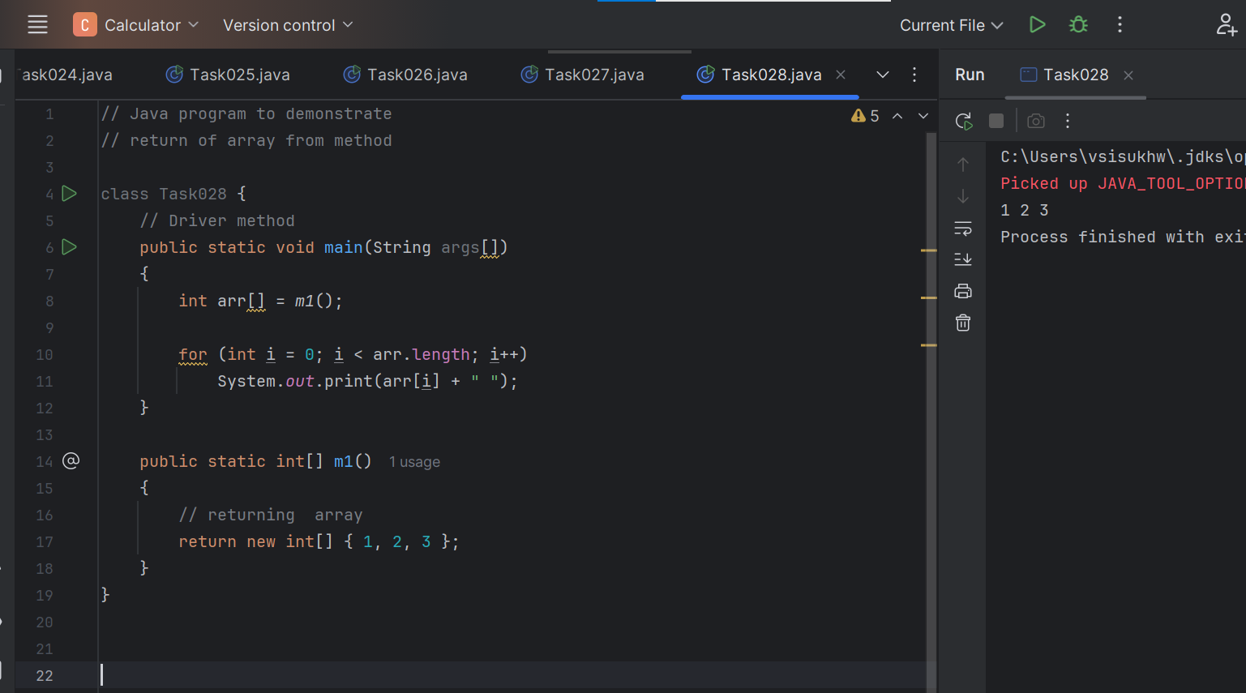

**Task 029**

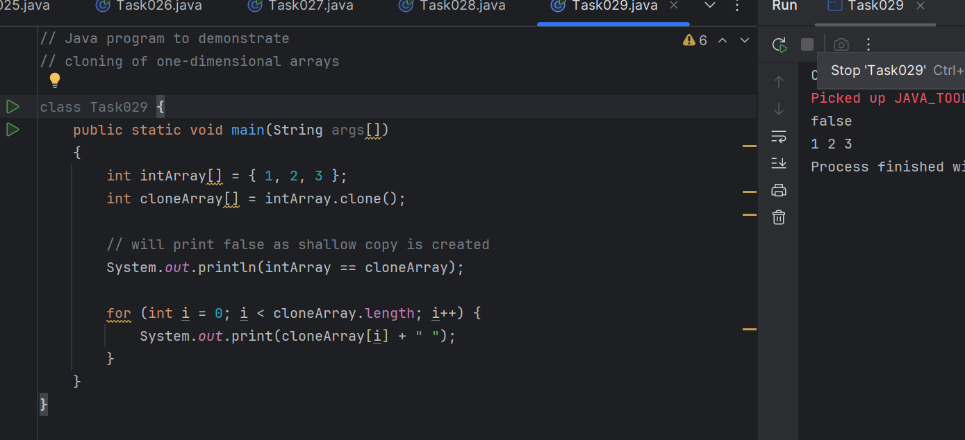

**Task 030**

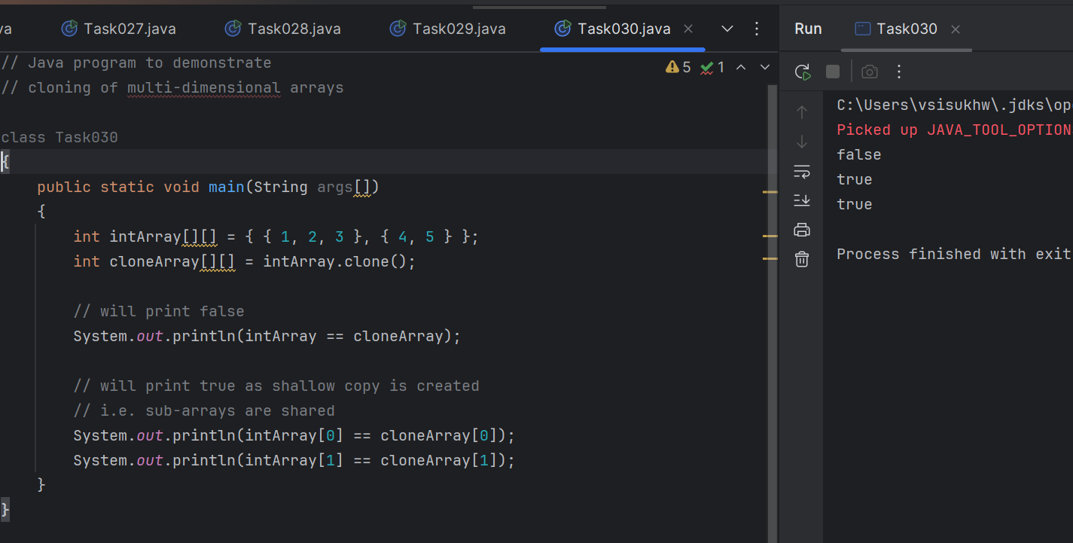

**Task 031**

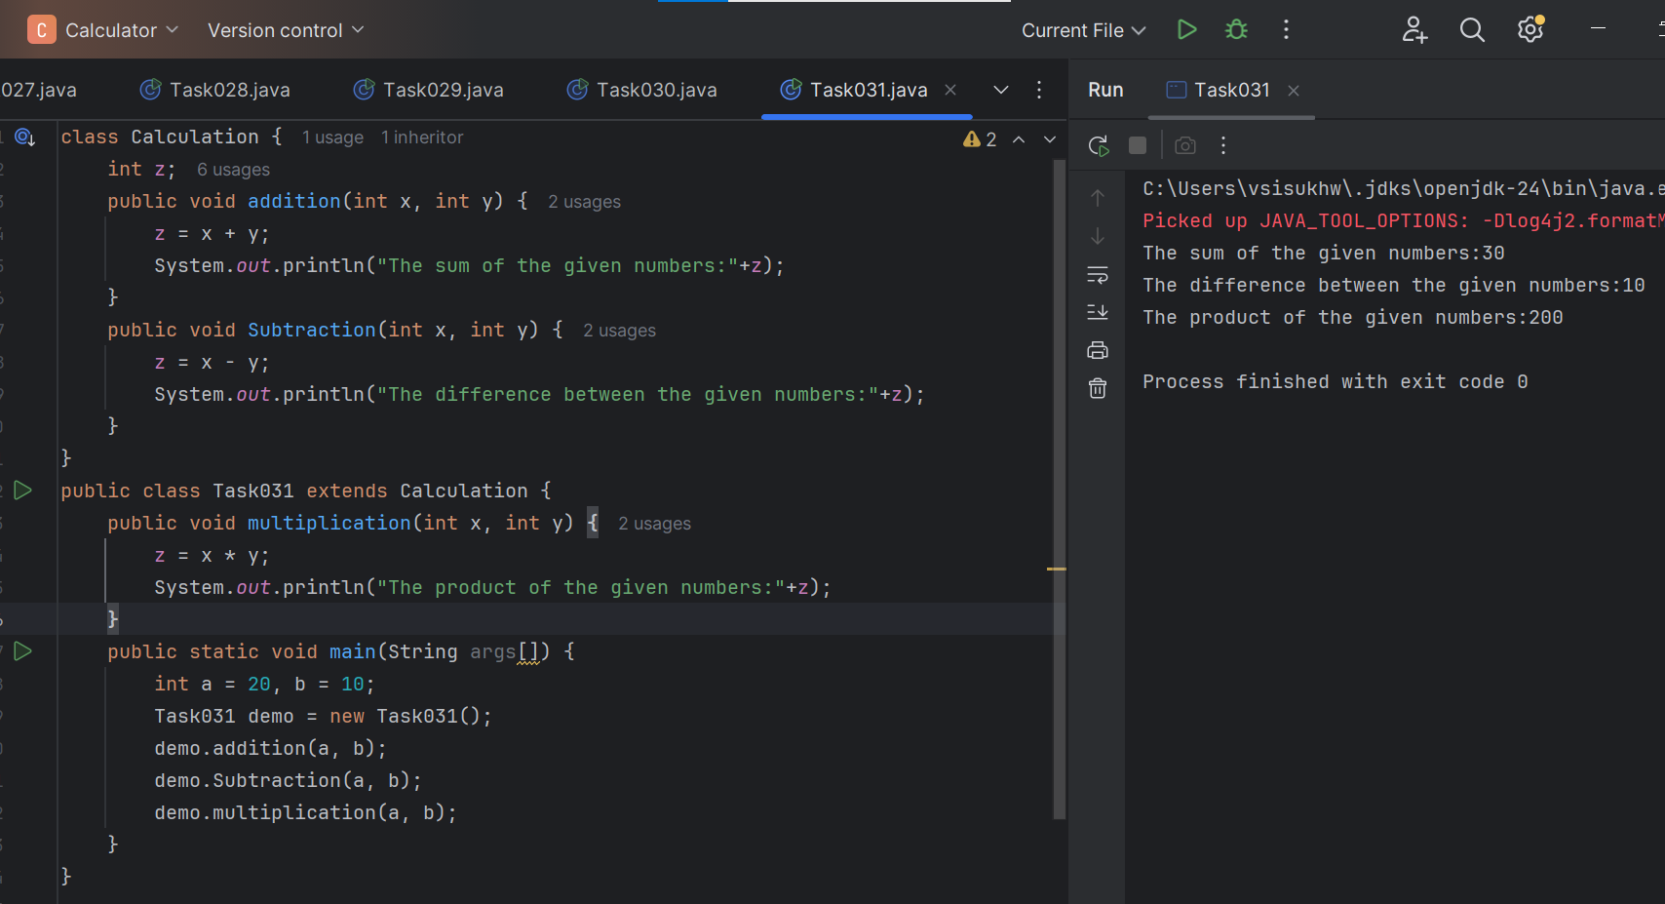

**Task 032**

**Here , its shown that multiple inheritance is not supported in java, it will show ERROR, when we extend two classes .**

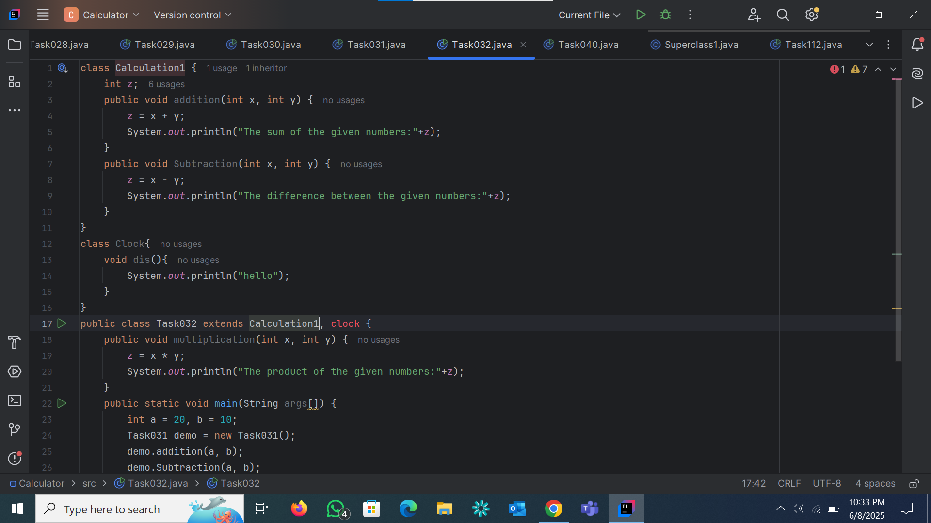

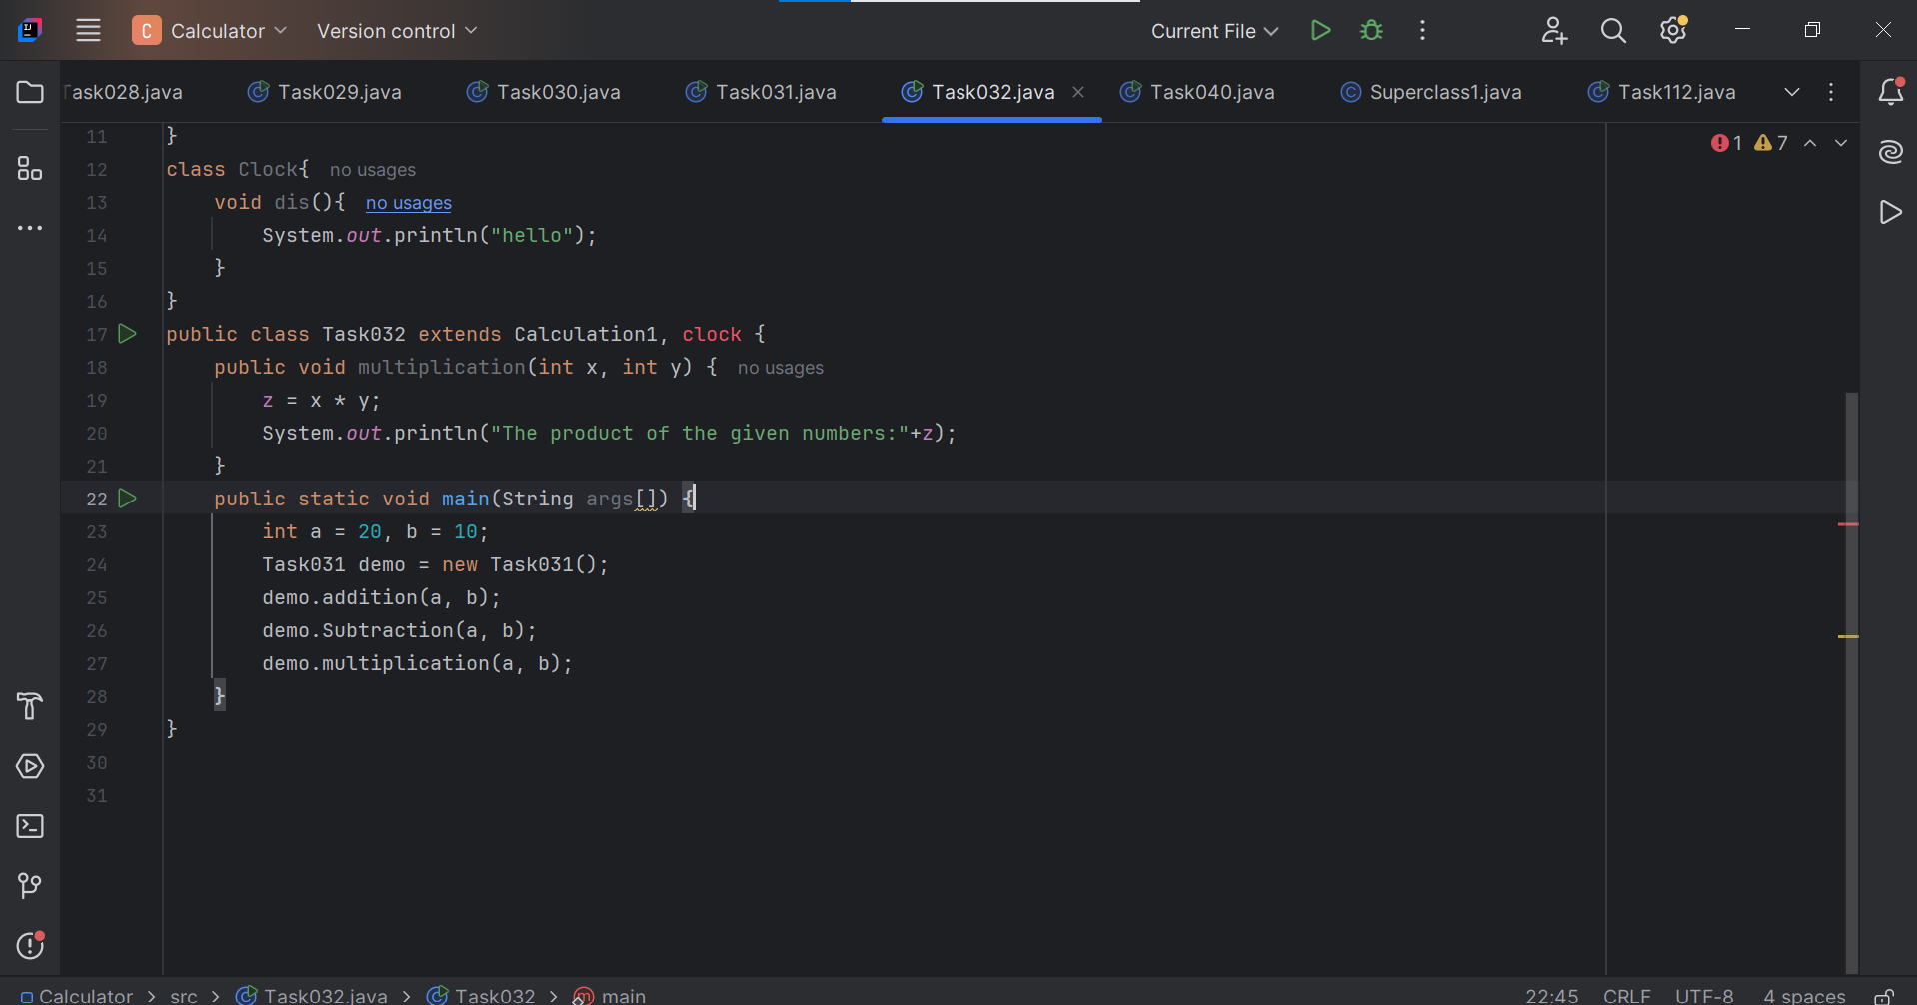

**Task 033**

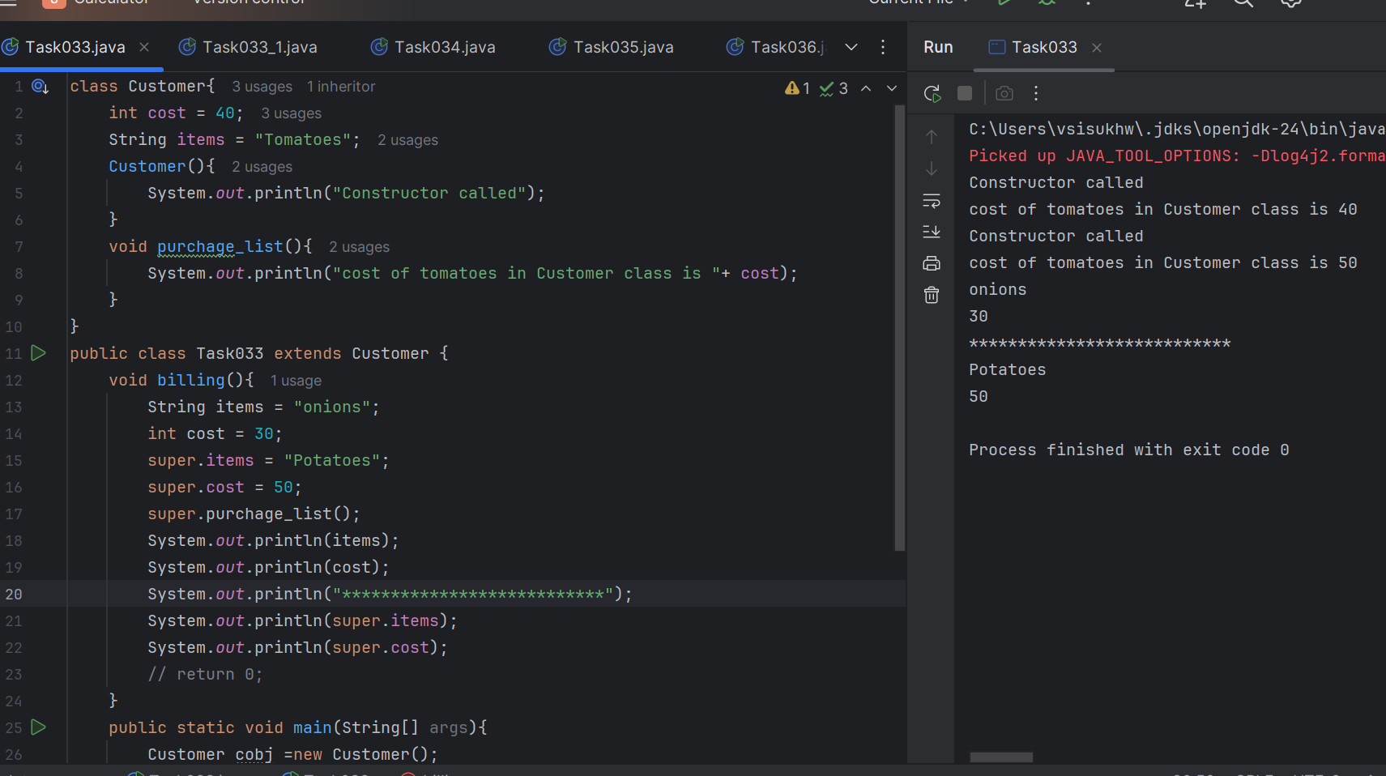

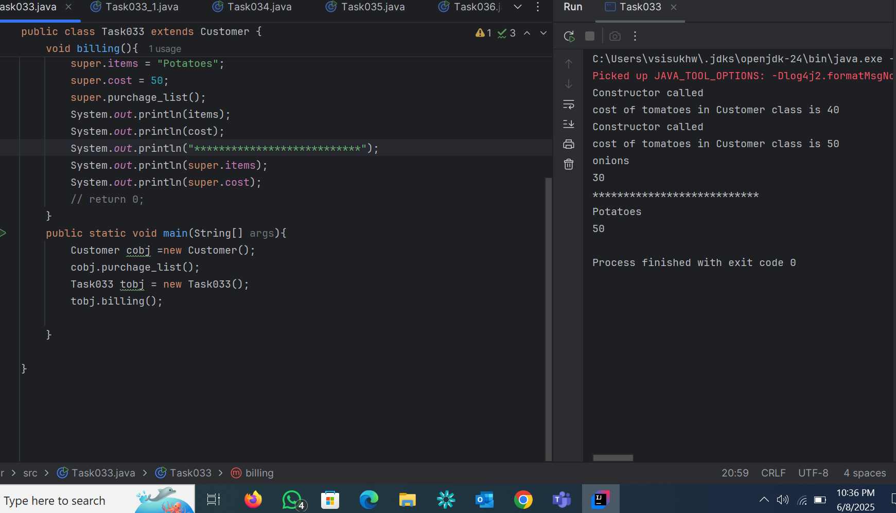

**Task 033_1**

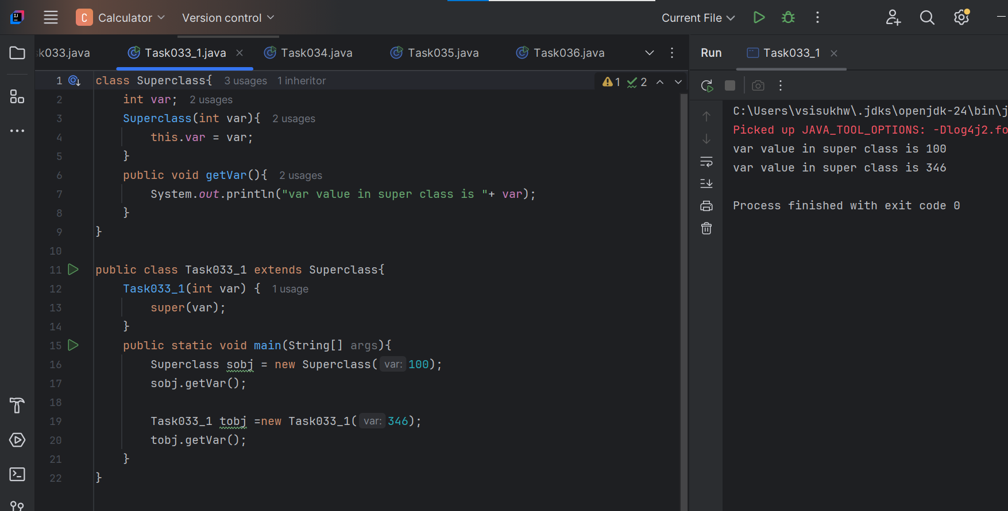

**Task 034**

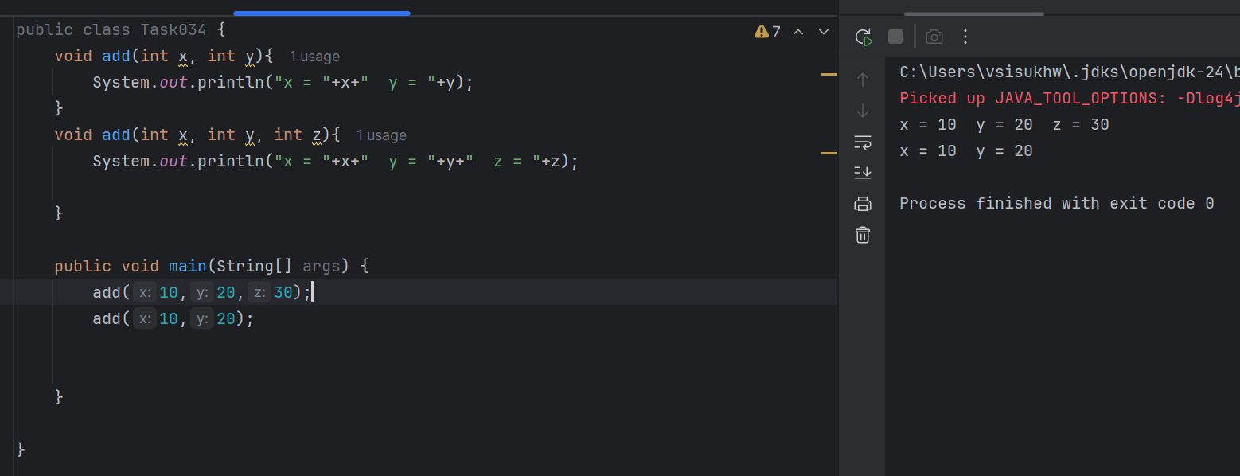

**Task 035**

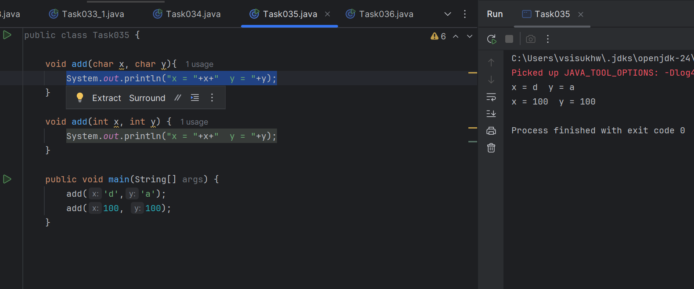

**Task 036**

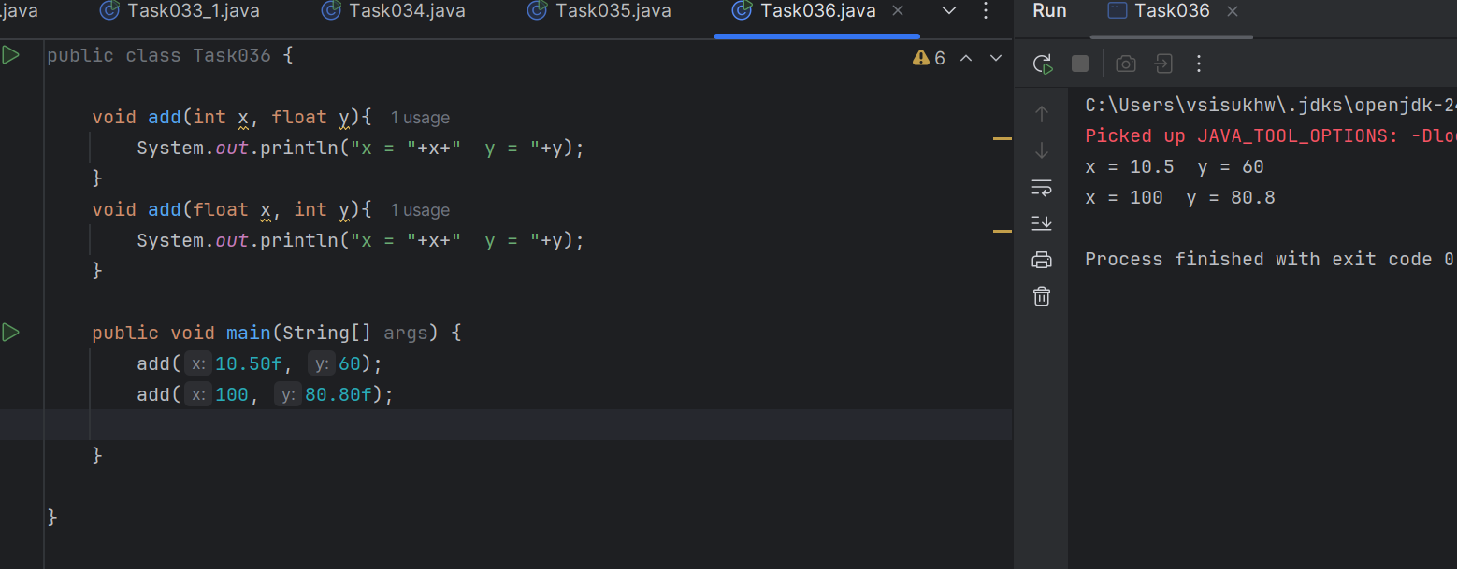

**Task 037**

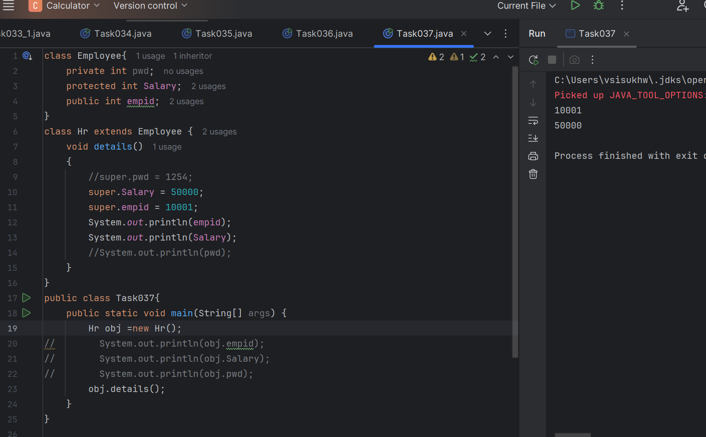

**It will not work if we comment off the commented statements, as pwd is private variable.**

**Task 038 and Task 039**

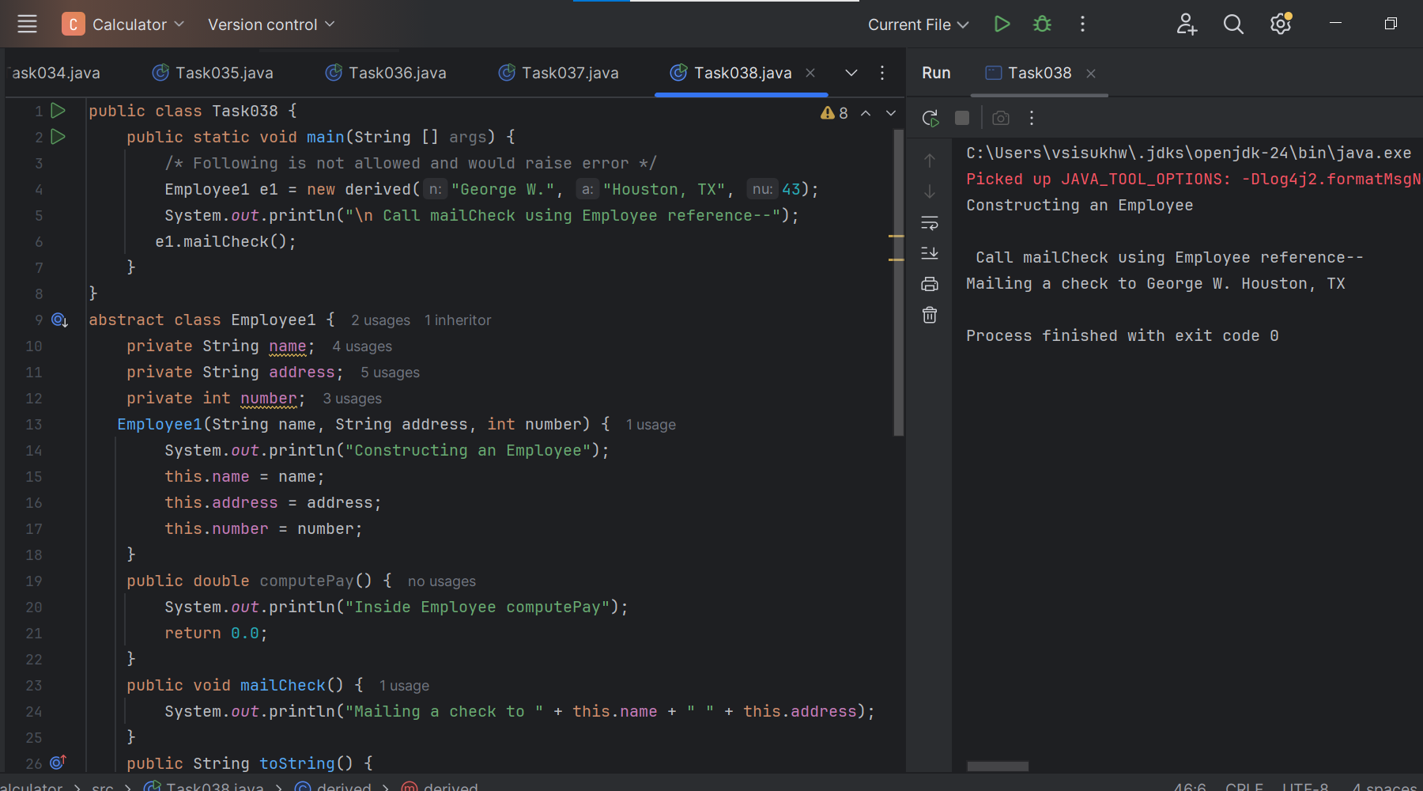

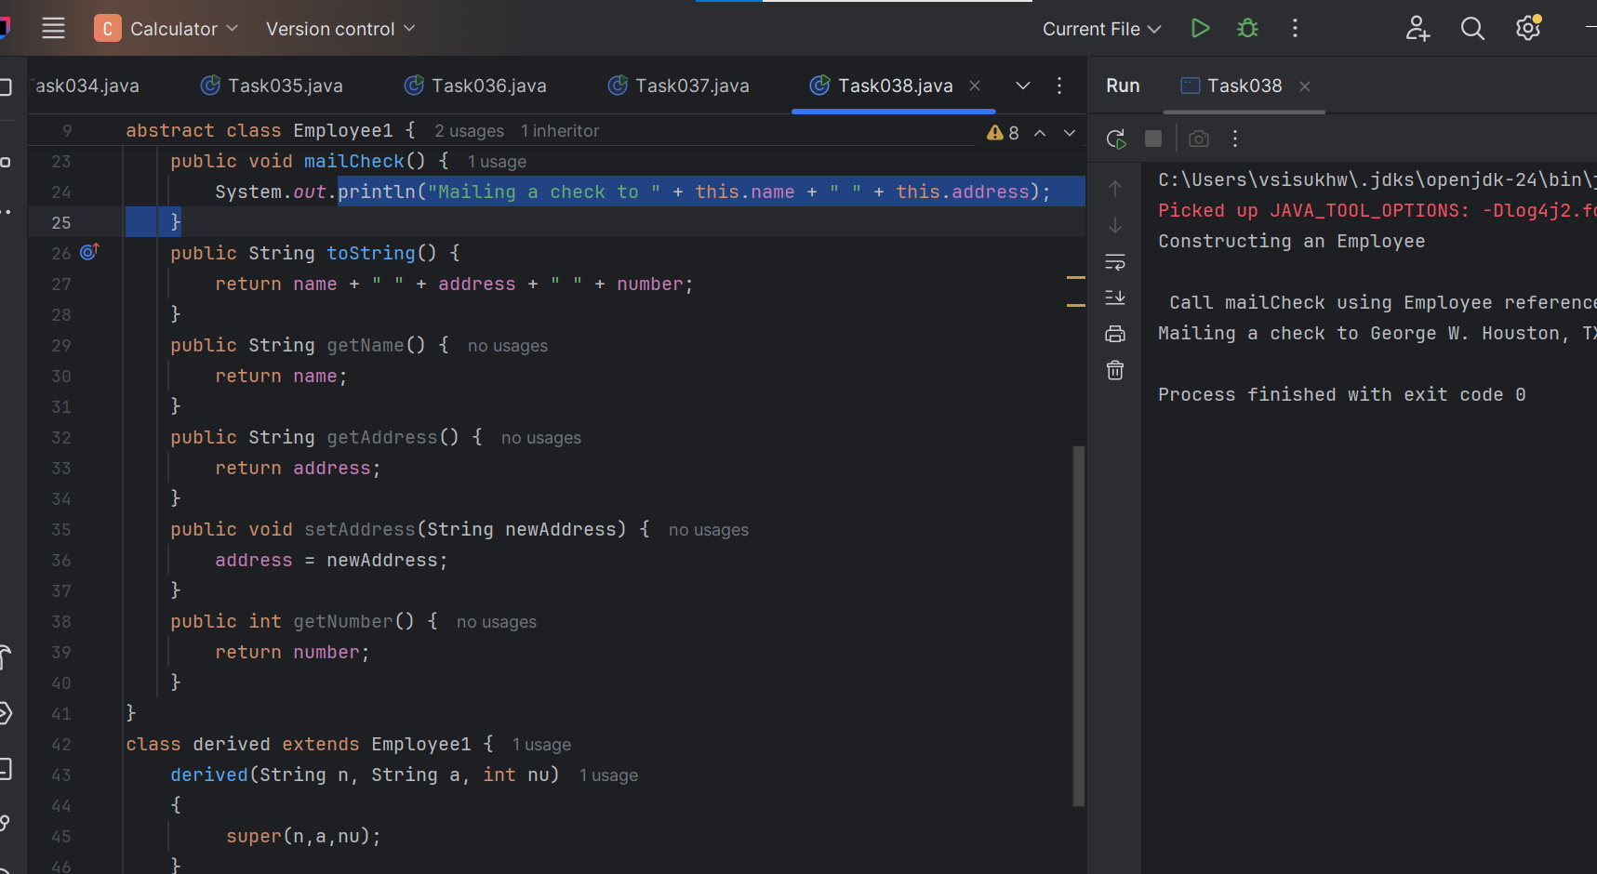

**Task 040**

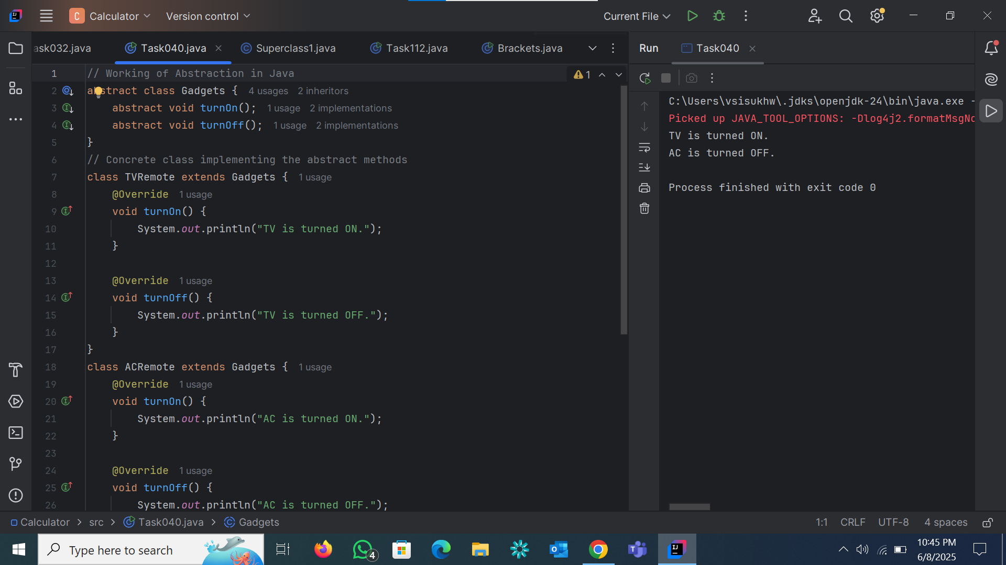

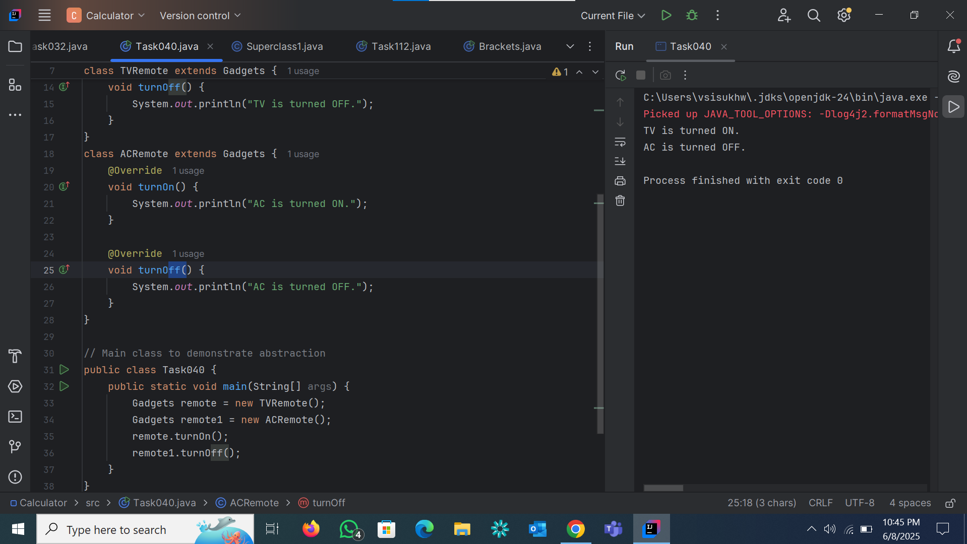

**Task 041**

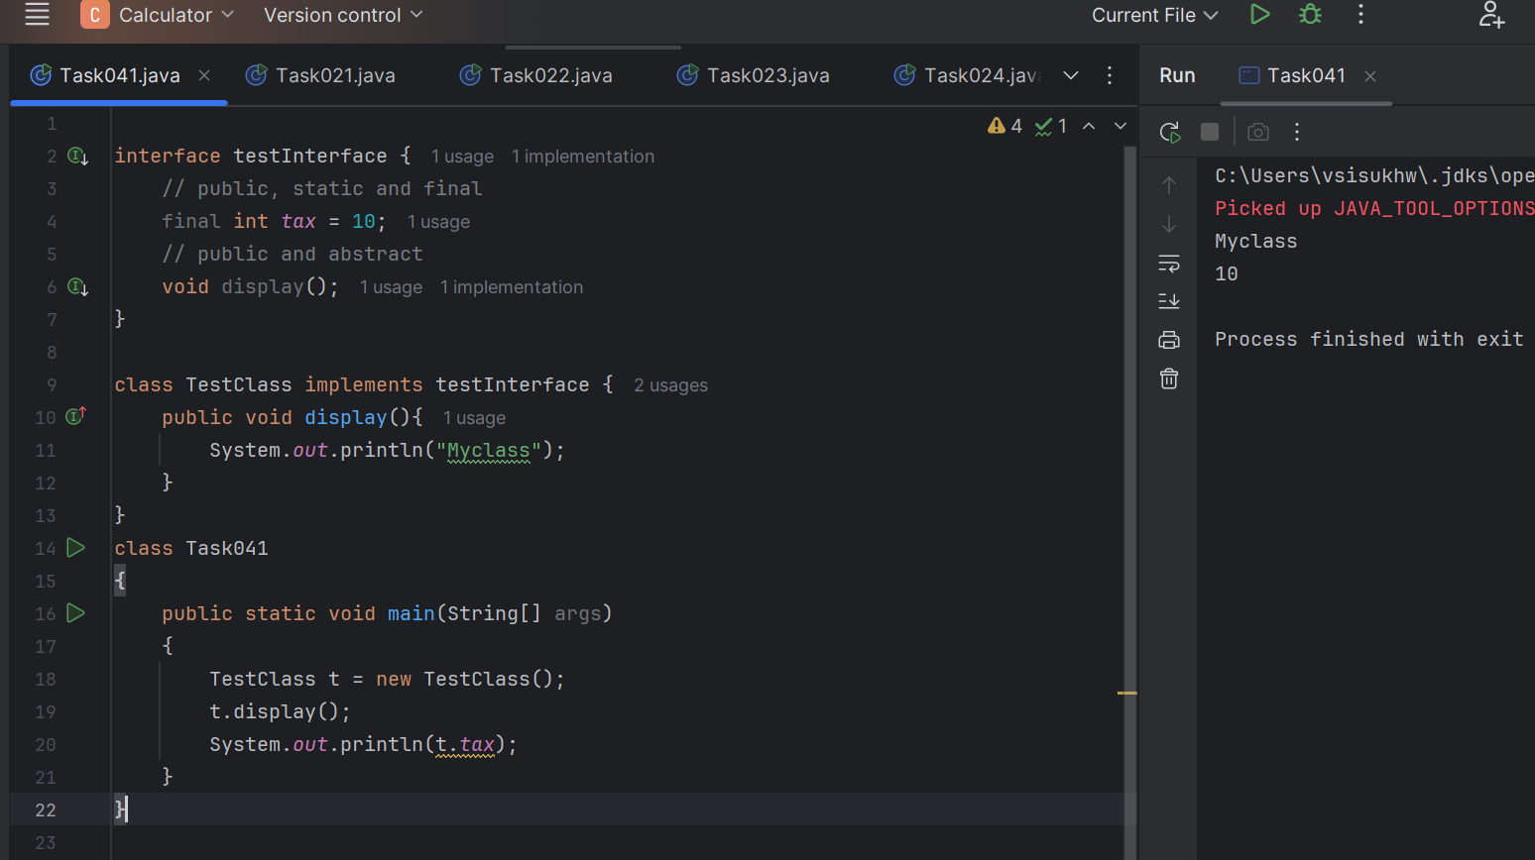

**Task 042**

**Final and constant differance**

final is a modifier in Java that can be applied to:

* Variables (fields, local, parameters)
* Methods
* Classes

In Java, a constant is a final variable that is also:

* public static final
* Typically written in UPPERCASE letters
* Assigned a value at the time of declaration